|  |  |  |  |  |  |
| --- | --- | --- | --- | --- | --- |
| Date | 24-Nov-22 | | | Tester Name | Mohammad Yusuf |
| Environment | Penfax - Test | | | Login used |  |
| Operating System | Windows | Version: | Update: | | |
| Software Used | Select Software | Version: | Update: | | |
| Select Software | Version: | Update: | | |
| Release version |  | | | | |
| Title |  | | | | |
| Test Type | Regression | | | | |
| Test Scenario |  | | | | |
|  |  | | | | |
| Expected Results |  | | | | |
| Pass/Fail | Select | | | JIRA# | N/A |

Describe your steps with screenshots:

Pre-condition: Login into the application.

Running the SPAF payment Batch as production.  
Go to Batches -> Payment Production

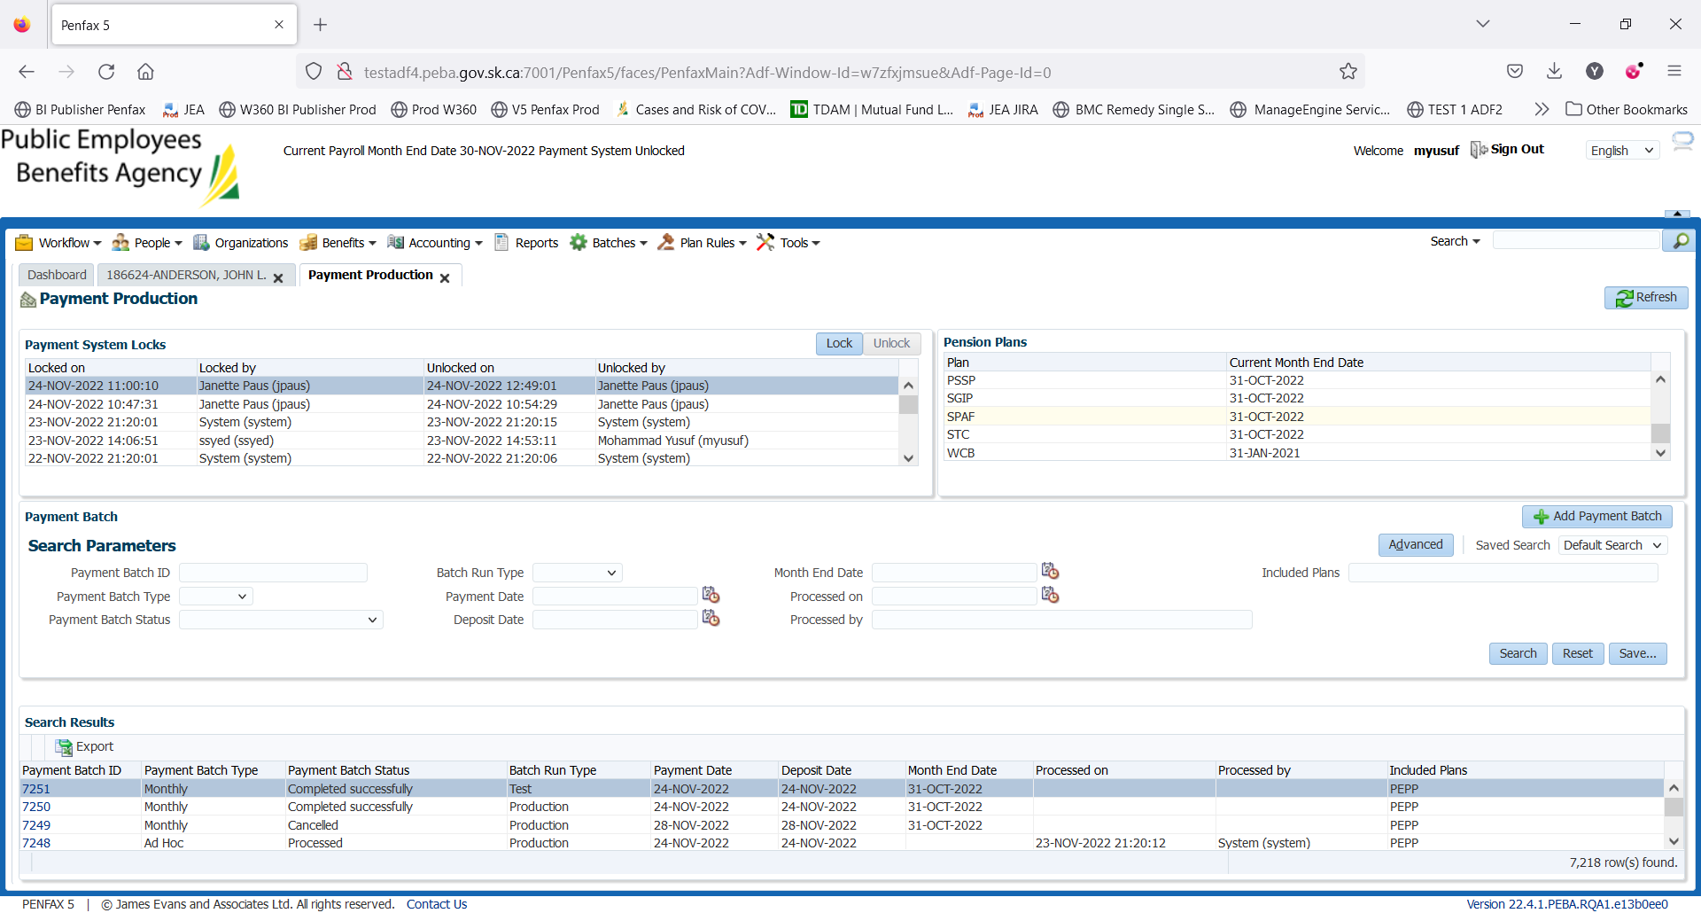

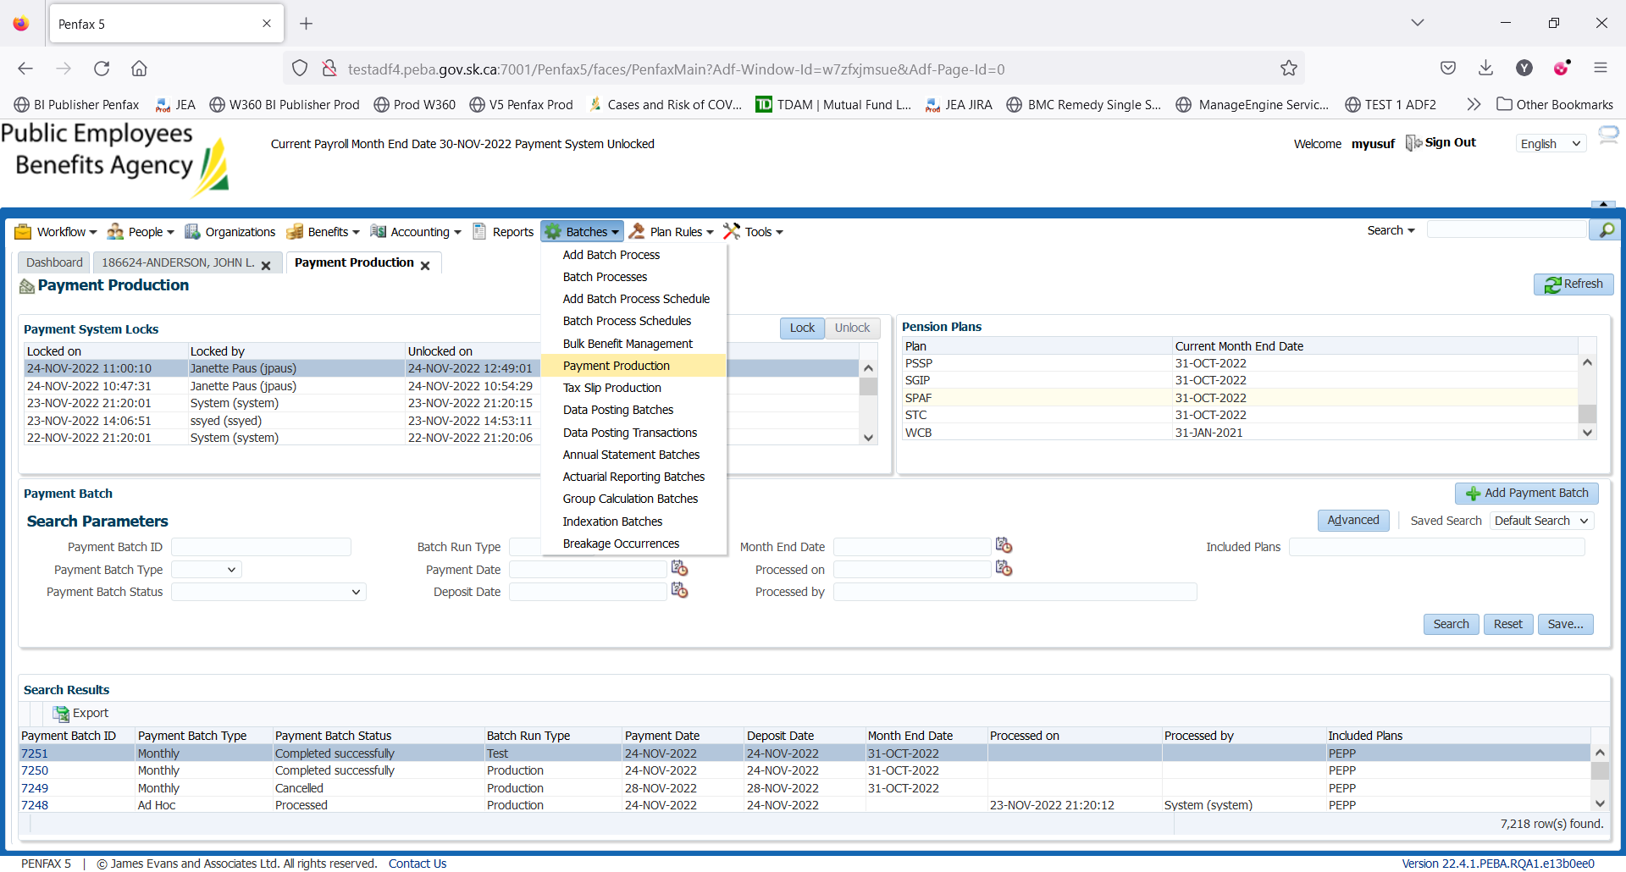

Click on Add Payment Batch. Enter details as below

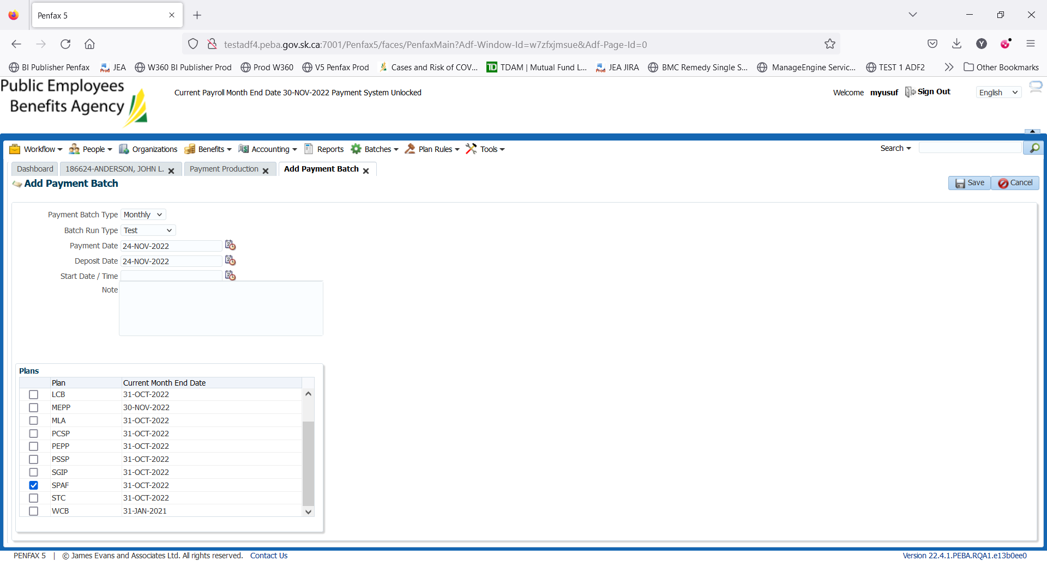

Run the batch. Always run the Batch Run Type: TEST and then Prod

Test: To remove all errors and then run the production batch.

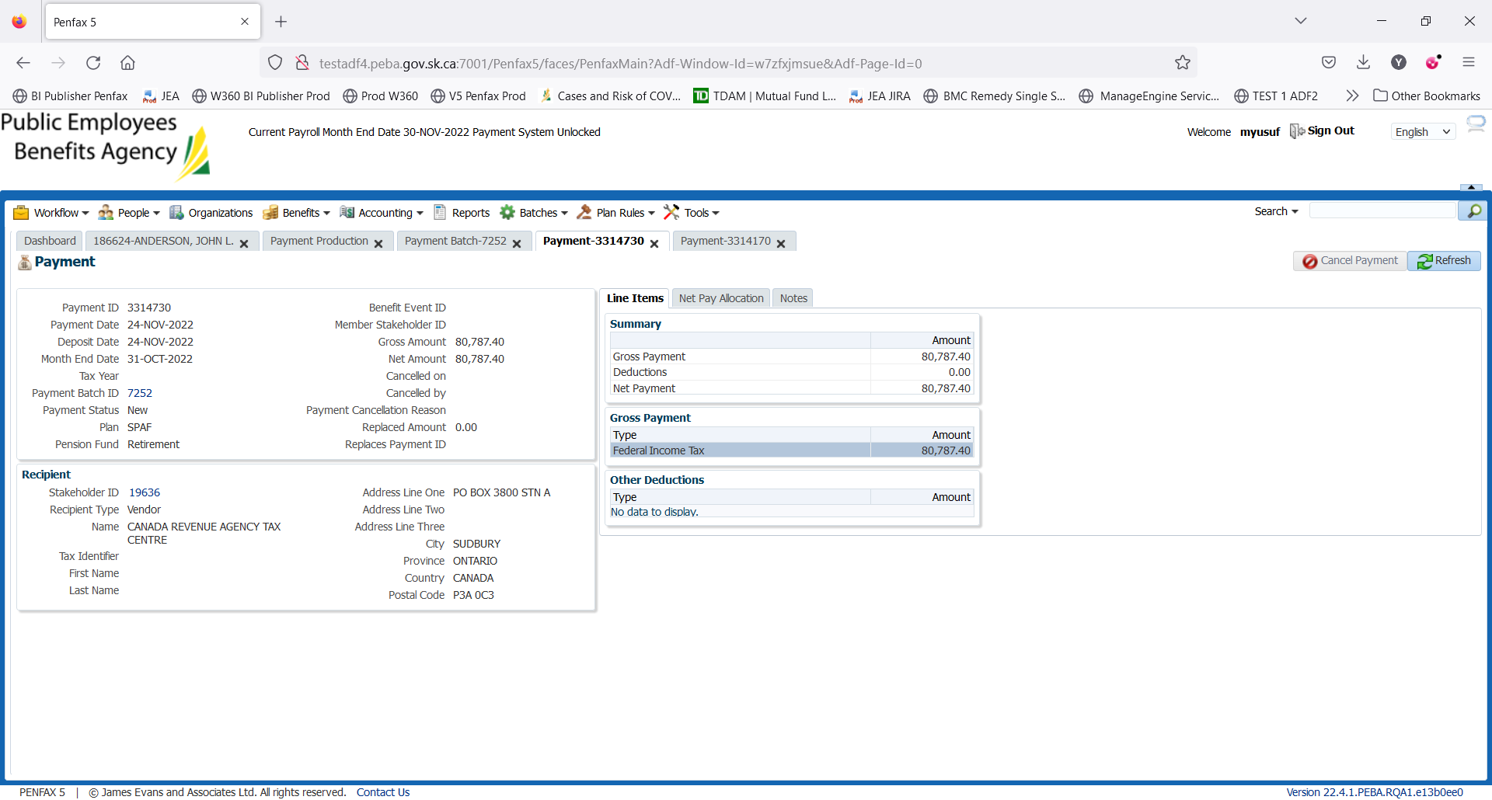

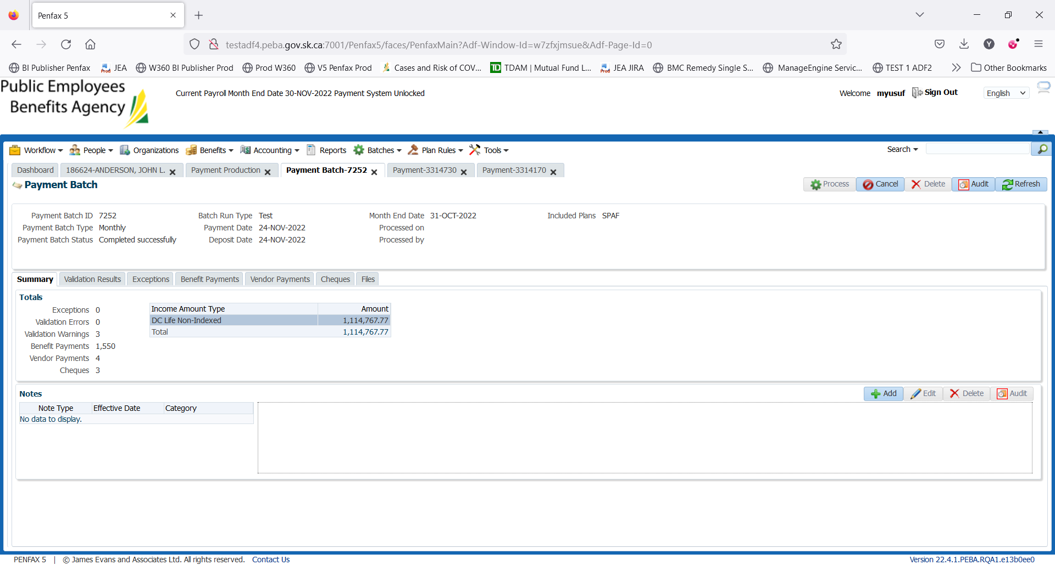

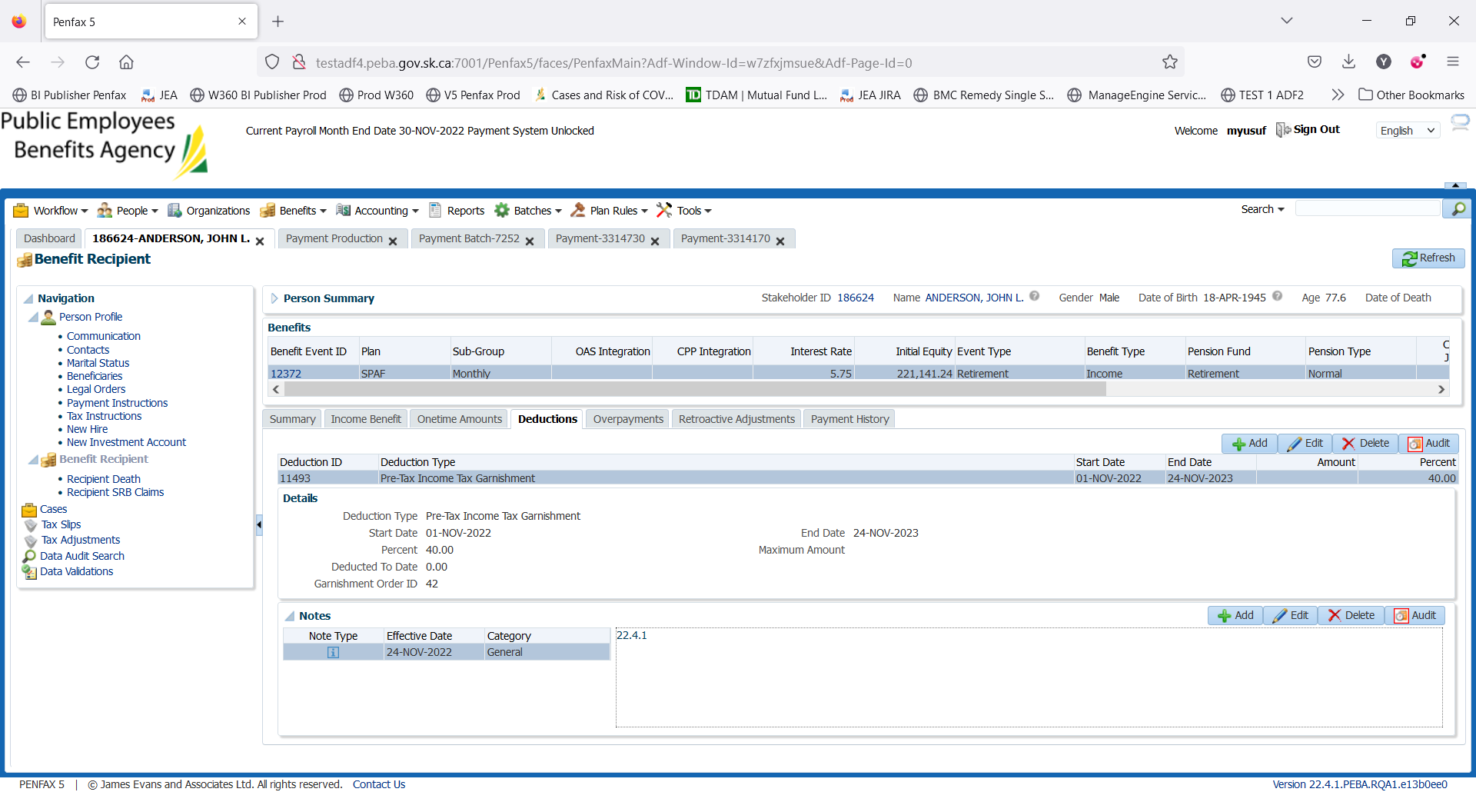

Please note deduction to date is Zero. The test failed. Functionality seems to be working good. I will check later when someone run the payroll batches for their testing

Reason: When payroll was run for SPAF payroll for Oct wasn’t run and we jumped to Nov so I don’t know if that’s what messed up the deduction for 186624.